PS LAB_05

Exercise

1. Import the dataset (’Exercise – Lab 05.txt’) into R and store it in a data frame called ”Delivery Times”.

2. Draw a histogram for deliver times using nine class intervals where the lower limit is 20 and upper limit is 70. Use right open intervals.

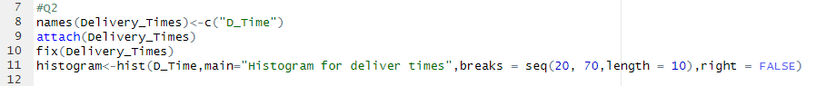





3. Comment on the shape of the distribution.



Most of the data is at the low end, forming a peak on the left, and a few high values stretch the graph out to the right.

4. Draw a cumulative frequency polygon (ogive) for the data in a separate plot.

